FULL LEGAL NAME | LOCATION (COUNTRY) | EMAIL ADDRESS | MARK X FOR ANY NON-CONTRIBUTING MEMBER
Kolapo Adedipe | Nigeria | adcolapsmm9@yahoo.com
Thant Thiha | Ireland | thantthiha10@gmail.com
Joseph Niyogushimwa | Rwanda | niyogushimwaj967@gmail.com | X

Statement of integrity: By typing the names of all group members in the text boxes below, you confirm that the assignment submitted is original work produced by the group (excluding any non-contributing members identified with an “X” above).
Team member 1 | Kolapo Adedipe
Team member 2 | Thant Thiha
Team member 3

Use the box below to explain any attempts to reach out to a non-contributing member. Type (N/A) if all members contributed.
Note: You may be required to provide proof of your outreach to non-contributing members upon request.
I tried to reach out to Joseph Niyogushimwa through discussion forums and email, and we had a meeting together on Google Meet. He agreed to do the portion of the assignment apportioned to him but as of now he had refused to make any contribution to this project.

Best Practices Handbook for
Modeling Volatility in Time Series

Challenge 1: Skewness
Definition
Skewness can be defined as an asymmetry measurement in a probability distribution. Simple mathematical expression to quickly approximate Pearson’s coefficient of skewness (Doane and Seward, 2011) is:
$Skewness = \frac{3(Mean - Median)}{Standard Deviation}$
In addition, skewness is denoted mathematically as Xi are the individual data points, X is the mean, s is the standard deviation, and n is the number of observations (Kim & Whites, 2004).
Description
Skewness quantifies whether the data distribution deviates from symmetry. Positive skew indicates a longer right tail (data stretched towards higher values) and Negative skew suggests a longer left tail (data stretched towards lower values). In addition, a positive skew suggests a longer right, while a negative skew suggests a longer left tail (Gujarati & Porter, 2009).
Demonstration
Using simulated financial data from Python codes (lognormal distribution with parameters mean = 0, sd = 1), we can observe the numerical characteristics of skewness. This simulated dataset represents financial log returns with the following properties:
Mean: 1.14
Median: 1.01
Standard Deviation: approx. 0.60
Applying the above Pearson’s skewness formula: Skewness ≈ 0.65
YF.download() has changed argument auto_adjust default to True
[*********************100%***********************] 1 of 1 completedMultiIndex([( 'Close', '^GSPC'),
( 'High', '^GSPC'),
( 'Low', '^GSPC'),
( 'Open', '^GSPC'),
('Volume', '^GSPC')],
names=['Price', 'Ticker'])
Skewness: -0.4794346290899373
This positive value of approx. 0.65 confirms the right-skewed nature of the distribution and mean exceeds median due to the influence of the higher values in the right tail.
Diagram
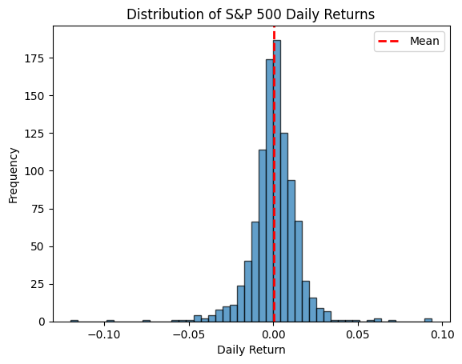
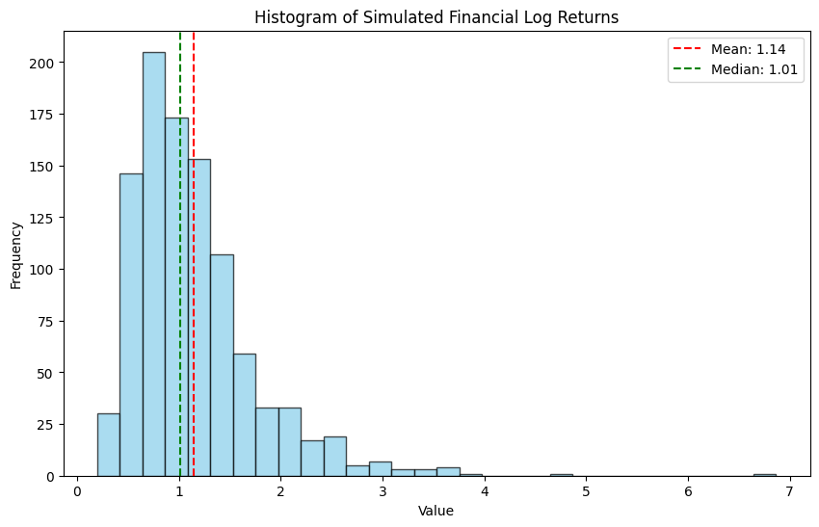

# For generating simulated dataset for financial log returns
np.random.seed(42) # For reproducibility
log_returns = lognorm.rvs(s=0.5, scale=np.exp(1), size=1000)
Diagnosis
There are several ways to diagnose the skewness in a given dataset. One of the quick ways is to examine the relationship between mean, median and mode.
- Mean > Median > Mode: Right-skewed Distribution
- Mode > Median > Mean: Left-skewed Distribution
- Mean ≈ Median ≈ Mode: Symmetric Distribution
Another way is to visualize the distribution with histograms, density plots, QQ plots to visually inspect the symmetry. Notable significant statistical tests such as the Pearson’s moment coefficient and visual inspection through kernel density plots can confirm skewness (Cont, 2001).
Normality Test p-value: 8.856738348809027e-53
Damage
If the skewness is not taken care of, it could lead to invalid statistical inferences because many statistical tests and models assume normally distributed data. These methods can produce incorrect p-values, confidence intervals and if trained with skewed data, they will have poor performance in capturing the behavior in the tails of the distribution. To buttress this point, skewness distributions distort volatility estimates, leading to mispriced options and incorrect risk assessments (Hull, 2018).
Directions
To address the skewness, one of the approaches we can use is data transformation such as logarithmic transformation and exponential transformation. Log transformation is effective for right-skewed data because it compressed higher values more than lower values. For right-skewed data, we can use log and square root transformations. For left-skewed, square, cube or exponential transformations can be used. Another notable way to address skewness, techniques such as Box-Cox transformations and using alternative volatility models like GARCH with skewed-t distributions are recommended (Bollerslev, 1986).

Challenge 2: Kurtosis / Heteroscedasticity
Definition
Kurtosis measures the heaviness of the tails in a probability distribution. Meanwhile, Heteroscedasticity refers to non-constant variance over time (Engle, 1982).
Description
Excess kurtosis indicates heavy tails and outlier presence, while heteroscedasticity suggests periods of high and low volatility.
Demonstration
Using financial time series, we observe volatility clustering in returns.
Diagram
A rolling standard deviation plot highlights changing volatility levels.
[*********************100%***********************] 1 of 1 completedMultiIndex([( 'Close', '^VIX'),
( 'High', '^VIX'),
( 'Low', '^VIX'),
( 'Open', '^VIX'),
('Volume', '^VIX')],
names=['Price', 'Ticker'])
Kurtosis: 9.273135461634897
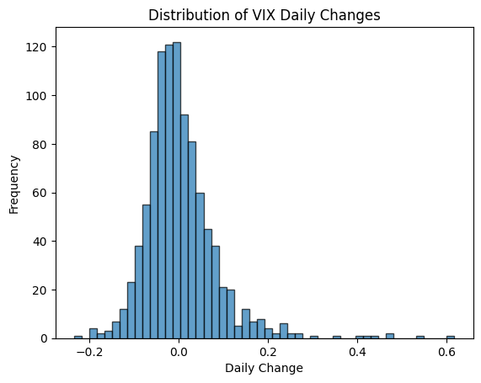
Breusch-Pagan test p-value: 0.0000
Significant heteroscedasticity detected. The variance of residuals is not constant.
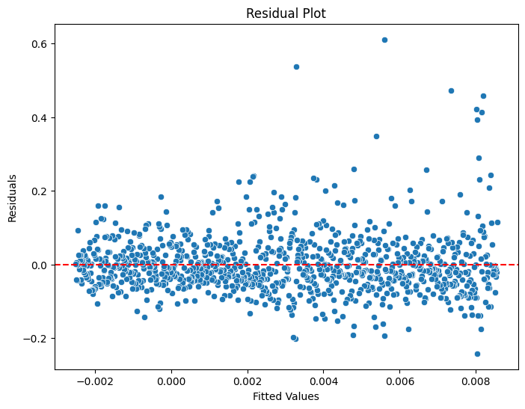
Breusch-Pagan test p-value: 0.0000
Significant heteroscedasticity detected. The variance of residuals is not constant.
Diagnosis
Tests such as the Jarque-Bera test for kurtosis and the Breusch-Pagan test for heteroscedasticity diagnose these issues (Brooks, 2019).
Damage
Excess kurtosis leads to underestimating tail risks, and heteroscedasticity affects predictive accuracy (Tsay, 2010).
Directions
Volatility models such as GARCH(1, 1) and EGARCH correct for these problems by modeling time-varying variance (Engle, 1982).

Challenge 4: Sensitivity to Outliers (WIP)
Definition
Outliers are data points that significantly deviate from the rest of the dataset, which can skew statistical analysis and lead to wrong conclusions. It is crucial to effectively manage the outliers for maintaining the integrity and reliability of the analysis. Outliers are also extreme values that deviate significantly from the dataset’s central tendency (Rousseeuw & Leroy, 1987).
Description
Outliers can be from measurement and data input errors, anomalies or genuine random phenomena and they can distort statistical models by influencing measures of central tendency and variability (Aguinis, Gottfredson & Joo, 2013).
Demonstration
Imagine a dataset of exam scores which consist of a mean of 80 and a standard deviation of 10. If one student scored 150 due to grading error, this one single outlier would significantly increase the mean and standard deviation. For example, the mean could rise to 85 and the standard deviation could increase to 15 which can lead to misrepresentation of the typical exam scores.
Diagram
We can use boxplot to detect outliers visually. For instance, if most exam scores fall between 70 and 90 and one score is 150, the boxplot will show this score as an outlier beyond the whiskers of the boxplot which indicates its significant deviation from the rest of the data points just by the look of it.
[*********************100%***********************] 1 of 1 completed
[*********************100%***********************] 1 of 1 completedMultiIndex([( 'Close', '^VIX'),
( 'High', '^VIX'),
( 'Low', '^VIX'),
( 'Open', '^VIX'),
('Volume', '^VIX')],
names=['Price', 'Ticker'])
Kurtosis: nan
The returns exhibit normal kurtosis.
Number of detected outliers in S&P 500 returns: 50
Price Close Daily Return
Ticker ^GSPC
Date
2020-02-24 3225.889893 -0.033514
2020-02-25 3128.209961 -0.030280
2020-02-27 2978.760010 -0.044163
2020-03-02 3090.229980 0.046039
2020-03-03 3003.370117 -0.028108
Diagnosis
Outliers can be identified using statistical methods such as Z-scores, modified Thompson tau, robust statistical techniques, the interquartile range (IQR) and visual tools like boxplots and histograms (Tukey, 1977). These tools can help detect outliers by highlighting data points that are very far away from the majority of the dataset. (Kutner et at., 2004)
Damage
Not paying attention to them can lead to biased statistical estimates, poor model fit and unreliable predictions and compromise of the analysis and any decision based on the data. (Aguinis, Gottfredson & Joo, 2013). For instance, In regression analysis, outliers can skew coefficients and inflate the errors of each datapoint which will result in misleading conclusions (Tabachnick & Fidell, 2013). Outliers also distort parameter estimates and increase model instability (Cont, 2001).
Directions
To effectively manage outliers and mitigate their impact on data models, we can use robust statistical methods which are designed to be less affected by outliers. These techniques include using the median instead of the mean and employing robust regression models such as Huber Regression or Least Trimmed Squares (LTS) Regression which can reduce the influence of outliers on the model (Rousseeuw & Hubert, 2011). In addition, using robust estimators such as median absolute deviation (MAD) or Winsorization reduces sensitivity to outliers (Huber, 1981).
FootNote
Advantage for using AI:
Needing less time to collect information and to evaluate it for accuracy as compared to using bibliographical research.

References
Bollerslev, T. (1986). Generalized autoregressive conditional heteroskedasticity. Journal of Econometrics, 31(3), 307-327.
Brooks, C. (2019). Introductory Econometrics for Finance. Cambridge University Press.
Cont, R. (2001). Empirical properties of asset returns: stylized facts and statistical issues. Quantitative Finance, 1(2), 223-236.
Doane, D. P. and Seward, L. E. (2011) ‘Measuring Skewness: A Forgotten Statistic?’, Journal of Statistics Education, 19(2), 9-10. doi: 10.1080/10691898.2011.11889611.
Engle, R. F. (1982). Autoregressive conditional heteroscedasticity with estimates of the variance of United Kingdom inflation. Econometrica, 50(4), 987-1007.
Gujarati, D. N., & Porter, D. C. (2009). Basic Econometrics (5th ed.). McGraw-Hill.
Hull, J. C. (2018). Options, Futures, and Other Derivatives (10th ed.). Pearson.
Kim, J., & White, H. (2004). On more robust estimation of skewness and kurtosis. Finance Research Letters, 1(1), 56-73.
Aguinis, H., Gottfredson, R. K. & Joo, H. (2013) Best-practice recommendations for defining, identifying, and handling outliers. Organizational Research Methods, 16(2), 270-301.
Kutner, M. H., Nachtsheim, C. J., Neter, J. & Li, W. (2004) Applied Linear Statistical Models. 5th ed. McGraw-Hill.
Tabachnick, B. G. & Fidell, L. S. (2013) Using Multivariate Statistics. 6th ed. Pearson Education.
Rousseeuw, P. J. & Hubert, M. (2011) Robust Statistics: Theory and Methods (with R). Wiley.
Rousseeuw, P. J., & Leroy, A. M. (1987). Robust Regression and Outlier Detection. Wiley.
Tsay, R. S. (2010). Analysis of Financial Time Series (3rd ed.). Wiley.
Tukey, J. W. (1977). Exploratory Data Analysis. Addison-Wesley.

